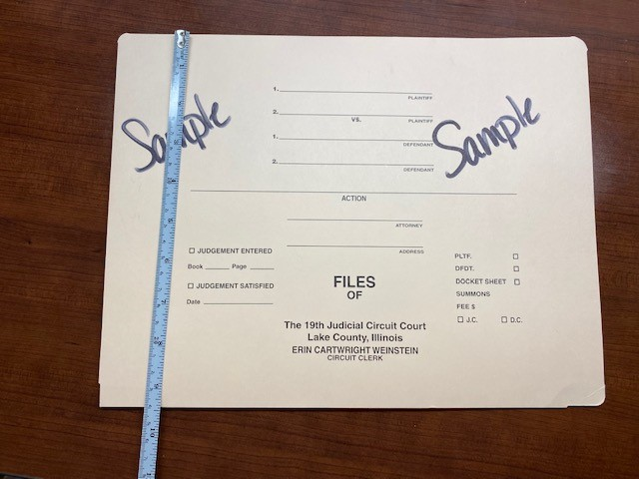

Circuit Court Clerk Folder Front Cover – See Specifications for correct dimensions

Circuit Court Clerk Folder Front Cover – See Specifications for correct dimensions

Circuit Court Clerk Folder Front Inter Pocket – See Specifications for correct dimensions

Circuit Court Clerk Folder Back Outer Cover – See Specifications for correct dimensions

Circuit Court Clerk Folder Back Outer Cover – See Specifications for correct dimensions

Circuit Court Clerk Back Inter Pocket - See Specifications for correct dimensions

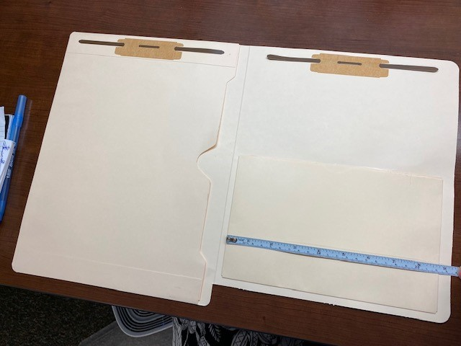

Circuit Court Clerk Back Inter Pocket - See Specifications for correct dimensions

19th Judicial Probation Services – Front Cover – See Specifications for correct dimensions

19th Judicial Probation Services – Front Inter Cover – See Specifications for correct dimensions

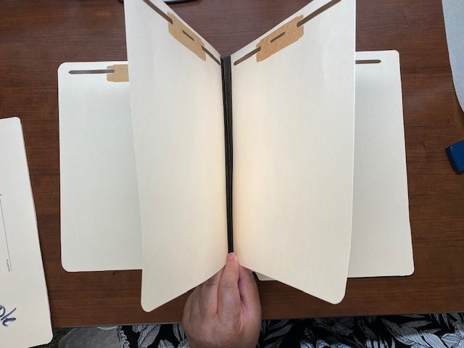

19th Judicial Probation Services – Inter Dividers – See Specifications for correct dimensions

19th Judicial Probation Services – Back Inter Cover – See Specifications for correct dimensions